**PSYCHOLOGY**

**Response 1**

**Biological Influences Test**

**Year 11 2021**

­­­

Time allowed for this paper

Working time for paper: 60 min 60 marks 7.5% of course

**Part A: Research Methods (12 marks)**

Read the following scenario and answer the questions that follow

Dr Savage is running a psychological experiment which examines the effect a new drug has on memory. She selects ten of her friends to take part in her experiment and administers the drugs by putting into their food when they come over to her house for dinner. She concludes that drag is effective in helping people’s memory as all of her friends are able to accurately recall the plot of the film they watched.

1a. Define the term sample in context of psychological research.

**(1 marks)**

* **A group of participants in a research study (1)**

b. Assess whether Dr Savage’s research is experimental or non-experimental.

**(3 marks)**

* **Experimental (1)**
* **‘researcher’ administered a drug (IV) (1)**
* **‘researcher’ asked participants to recall the evening (DV) (1)**

c. Using examples, identify two ethical issues with Dr Savage’s study.

**(4 marks)**

* **Identification of ethical issues (responses can include deception, right to withdrawal, protection from harm, informed) (2 x 1 mark)**
* **Example from scenario (2 x 1 mark)**

d. Identify whether Dr Savage’s conclusion is a valid one, and explain with reference to research method and sample.

**(4 marks**)

* **No (1)**
* **Sample too small ergo cannot be generalised (1)**
* **No pre-test re: memory so cannot establish whether there’s been a change in memory (1)**
* **No control group to compare results to (1)**

**Part B: Biological Influences (50 marks)**

2

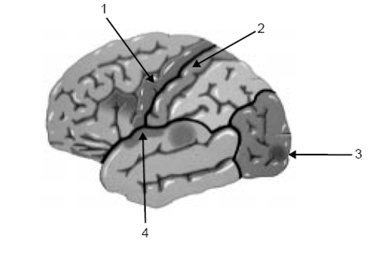

a. Identify all four lobes of the cerebral cortex, as shown above, and outline their function.

**(6 marks)**

* **1 – Frontal Lobe (1/2)**
* **2 – Parietal Lobe (1/2)**
* **3 – Occipital Lobe (1/2)**
* **4 – Temporal Lobe (1/2)**
* **Correct functions corresponding to each lobe (4 x 1 mark)**

b. With reference to an appropriate structure, explain why the limbic system is often referred to as the emotional nervous system.

**(2 marks)**

* **endocrine system responds to emotional stimuli**

e. Identify a structure of the hindbrain and outline its function.

**(2 marks)**

* **Identifies structure (can include cerebrum, pons or medulla oblongata) (1)**
* **Correctly outlines function (1)**

3a. Identify and describe the structure that connects the two hemispheres of the brain.

**(2 marks)**

* **Corpus callosum - a thick band of fibres in the middle of the brain that allows messages to be sent from one hemisphere to the other**

3.b: Dr Quinn has a patient who has damaged the right side of their brain. Explain the types of impairments this patient will have.

**(2 marks)**

* deficiency with vision: recognise only parts of a picture/symbols rather than seeing the whole picture (1)
* Issues with creative thinking (1)
* Only can control left side of body (1)

[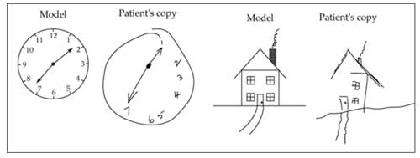](http://www.google.com.au/url?sa=i&source=images&cd=&ved=0CAgQjRw4Ew&url=http://www.joinstick.net/psychology/%E0%B8%AD%E0%B8%B2%E0%B8%81%E0%B8%B2%E0%B8%A3%E0%B8%9A%E0%B8%B2%E0%B8%94%E0%B9%80%E0%B8%88%E0%B9%87%E0%B8%9A%E0%B8%97%E0%B8%B2%E0%B8%87%E0%B8%AA%E0%B8%A1%E0%B8%AD%E0%B8%87-8.html&ei=8hyRVM-cKqbLmAXA44KYCQ&psig=AFQjCNF-QRyq4JQHDg51EKiLhkMuvfCmvg&ust=1418882674762364)

c. Dr Quinn has another patient who has suffered a stroke. This patient is having difficulty recognising faces, and when asked to, he draws the above picture.

**(1 marks)**

* **Right hemisphere (1)**

d. With reference to the symptoms, assess which part of the cerebral cortex has been damaged.

**(3 marks)**

* **The occipital lobe – receives and processes visual information (1)**
* **This lobe the brain is partly responsible for our ability to recognize faces. (1/2)**
* **Parietal Lobe (1)**
* **neglects objects drawn on the left side of a picture (1/2)**

4a. Outline how electroencephalography is used to investigate brain function.

**(2 marks)**

* **Measures electrical activity / brain wave (1)**
* **Used for diagnosing disorders Parkinson’s and epilepsy / measuring states of consciousness (1)**

b. Dr Brennan wants to find out which areas of the brain are activated when are recalling memories; should he use a CAT scan or a PET scan. Explain with reference to the type of images the scanning techniques produce. **(2 marks)**

* **PET scan (1)**
* **Shows dynamic images which indicate function (1)**

c. A patient is complaining of headaches and Dr Cruxon thinks it may be a tumour. Which form of brain scanning or external recording device/s would she use and why.

**(3 marks)**

* **CAT or MRI (1)**
* **Outline of imaging technique (1)**
* **Shows structure, therefore can be used to identify structural abnormalities such as tumours (1)**

d. Outline another brain imaging technique Dr Cruxon could use for this patient and evaluate it in comparison to the technique mentioned in the question above, with reference to the strengths and weaknesses of both.

**(5 marks)**

* **CAT or MRI – outline (1 mark)**
* **Strength of CAT (1)**
* **Strength of MRI (1)**
* **Weakness of CAT (1)**
* **Weakness of MRI (1)**

e. Identify one case study that has been influential in investigating brain function and outline its contribution to this area of research.

**(4 marks)**

* **Phineas Gage (1)**
* **Outline of study (1)**
* **Shows the importance of the frontal lobe re: personality (1)**
* **Shows that brain damage is localised, only certain skills/attributes affected. (1)**

f. Outline one limitation associated with case studies as a method for investigating brain function case studies. **(2 mark)**

* **Cannot be generalised to the population (1)**
* **are specific relating to one individual. (1)**

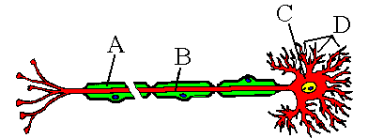

5. Identify the four structures labelled on the diagram above, and their functions.

**(6 marks)**

* **A – Myelin sheath (1/2)**
* **B - Axon (1/2)**
* **C – Cell Body (1/2)**
* **D – Dendrite (1/2)**
* **1 mark for each correct function**

6. Exercise provides psychological health benefits, as well as physical. Justify this statement with reference to evidence.

**(6 marks)**

* Exercise increases the production / releases chemicals such as serotonin and endorphins (1)
* Some studies have indicated that exercise can help with depression. (1)
* This causes the psychological effect of boosted mood. (1)
* Name : Wendy Suzuki (1)
* Method : case study on herself, and literature searches (1)
* Findings: Increase in focus, attention and growth of the hippocampus (memory) (1)

**END OF TEST**